**Size vs Aberration Comparison (side by side)**

Appendix C – Questionnaire Module

Figure-1: Aberration effect comparison

**1. Select the degree to which you agree or disagree with each of the following statements:**

1. The left circle without aberration is equal to right circle

|  |  |  |  |  |
| --- | --- | --- | --- | --- |
| Strongly  agree | Partially  agree | Neither agree nor disagree | Partially  disagree | Strongly  disagree |

1. The left circle including aberration is equal to right circle

|  |  |  |  |  |
| --- | --- | --- | --- | --- |
| Strongly  agree | Partially  agree | Neither agree nor disagree | Partially  disagree | Strongly  disagree |

1. The left circle including aberration is bigger than right circle

|  |  |  |  |  |
| --- | --- | --- | --- | --- |
| Strongly  agree | Partially  agree | Neither agree nor disagree | Partially  disagree | Strongly  disagree |

**Size vs Aberration Comparison (page shifting)**

Figure-2: With aberration

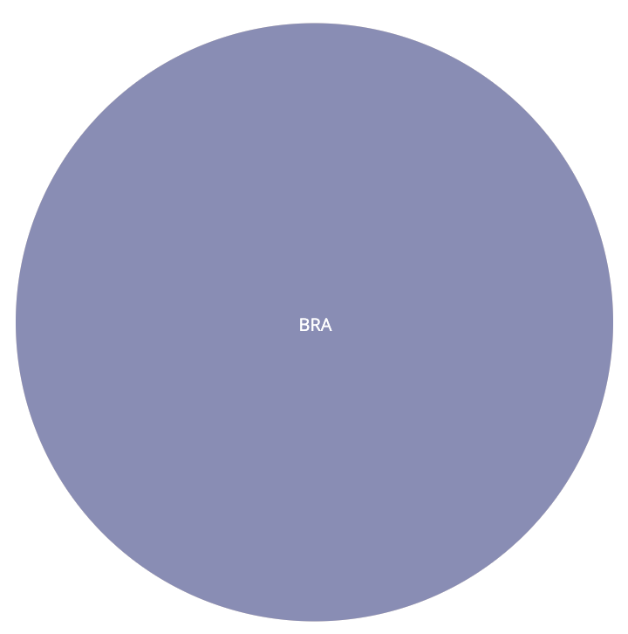

Figure-3: Without aberration

**2. Select the degree to which you agree or disagree with each of the following statements:**

1. Circle in Figure-2 without aberration is equal to Circle in Figure-3

|  |  |  |  |  |
| --- | --- | --- | --- | --- |
| Strongly  agree | Partially  agree | Neither agree nor disagree | Partially  disagree | Strongly  disagree |

1. Circle in Figure-2 including aberration is equal to Circle in Figure-3

|  |  |  |  |  |
| --- | --- | --- | --- | --- |
| Strongly  agree | Partially  agree | Neither agree nor disagree | Partially  disagree | Strongly  disagree |

1. Circle in Figure-2 including aberration is bigger than Circle in Figure-3

|  |  |  |  |  |
| --- | --- | --- | --- | --- |
| Strongly  agree | Partially  agree | Neither agree nor disagree | Partially  disagree | Strongly  disagree |